**Project Background:**  
  
Our project is called “**ATM Banking System**”, in short “ATM Banking”.  
  
Bangladesh is a developing country. But, still, there are some areas which is underdeveloped. The banking system is somewhere developing, and somewhere remains underdeveloped.  
  
ATM stands for Automated teller machine. Presently this is one of the most improvised ways of transaction. As people do not feel comfortable to carry huge amount of money in our country for huge security issue, they use ATMs. By adding new features and also increasing the security issues it may provide more supremacy than it today. As a result, life becomes reliable and lighten up. Here in this paper we tried to give a full description, how Advanced ATM works and comparisons among the general ATM services of different banks in Bangladesh. We also tried to focus few problems and few suggestions how to eliminate these problems.  
  
Our project’s aim is to make the whole banks ATM system of Bangladesh improved to a great extent. But we can’t do that unless all the banking systems are highly updated & must come with advanced feature & security updates.  
  
**Right now the state of the current ATM system are:**  
1. Normal & too basic types mechanism setup where in other country they are using latest mechanism setup.  
2. Poor tracking system.  
3. Poor card protection system.  
4. Poor service by operator.  
5. Poor data server maintenance.  
6. No stable & secured website for ATM system of Bangladesh  
  
**Project Objective:**  
  
Our objective is to create a more improved ATM banking system for banks of Bangladesh and make banking more secured & immediate emergency usable, safe and easier for people. But, to improve this system, we need to accomplish the following things:

1. Highly secured encrypted database.  
2. Improved database & server Tracking System  
3. Improved Online transaction  
4. All advanced Features in ATM machine.   
5. Highly secured website for everything about banking detail.  
6. Advanced featured ATM in booth for everything in every crowed place, at any need or emergency that can be most usable for fastest banking & transaction all over the world.  
 **Solution Process:**  
**Highly secured encrypted database:**

We need highly secured encrypted banking database. This will keep safe all banking account info from unauthorized abuse and it will keep hackers away from money theft.

**Improved database & server Tracking System:**

Database & server tracking system must need check & update daily to kill the bugs and keep ATM banking safe.

**Improved Online transaction:**

Online transaction must need to be improved by daily newest feature & update and by fixing security bugs daily. It will also keep online shopping safe for daily use.

**All advanced Features in ATM machine:**

It badly seen that our ATM machines doesn’t contain full features like western country serves in their country only because of poor security & maintenance of our country. Security & maintenance must need provide properly for our country to improve ATM system to safest place.

**Highly secured website for banking detail:**

Banks must provide highly secured banking web for checking everything detail from anywhere of World like E-commerce websites Amazon, AliExpress etc. They are the best examples of online highly secured payment transaction that have ever made by security researchers.

**Advanced featured ATM in booth:**

ATM must contain multiple features in one place like Withdraw, balance check, deposit, emergency loan (account type or user dependent), loan calculator, loan total with original for payment, monthly loan payable etc too many advanced features can be added to ATM. In western country, they’re now using those all but we’re now just hearing from them. We must make our dream true for being safe in future.

**Project Risk Management:**  
  
Because of spreading online transaction, currency might get hacked by hacker to their bank accounts. To avoid such cases, the website will need to secure the detailed information of the buyers. If one person transacts huge amount often or do many transactions at once, needs to be suspected. Without authorization these features can’t be provided by bank for any general user’s purpose.

**Graphical Overview:**

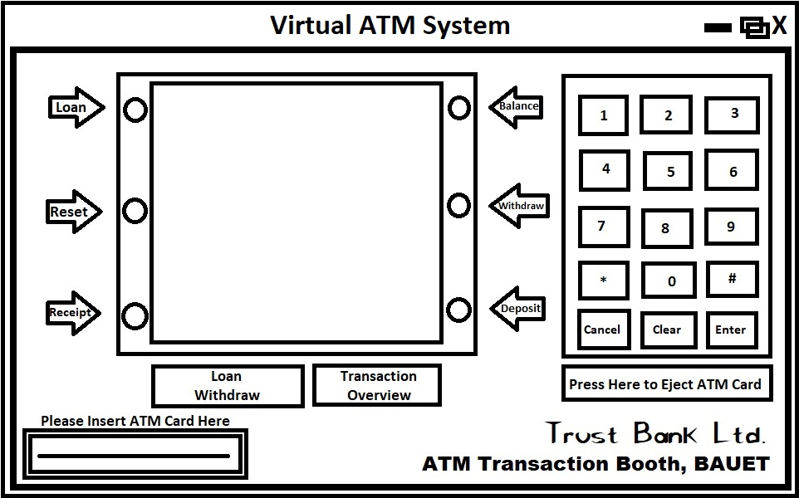  
  
**Conclusion:**This Advanced ATM Banking System can not only just improve the security sides, but also the needy sides too. Our Country’s ATM Banking System now is like having a sharp brain, but with weaker limbs. Body doesn’t work properly like the mind tells it to do.  
  
That’s why we are here.

With your approval and support, we can make Bangladesh more developed than it already is.